**D3 Interactivity //Mouse hovering, Tooltip and Sonification**

OUTPUT SCREEN

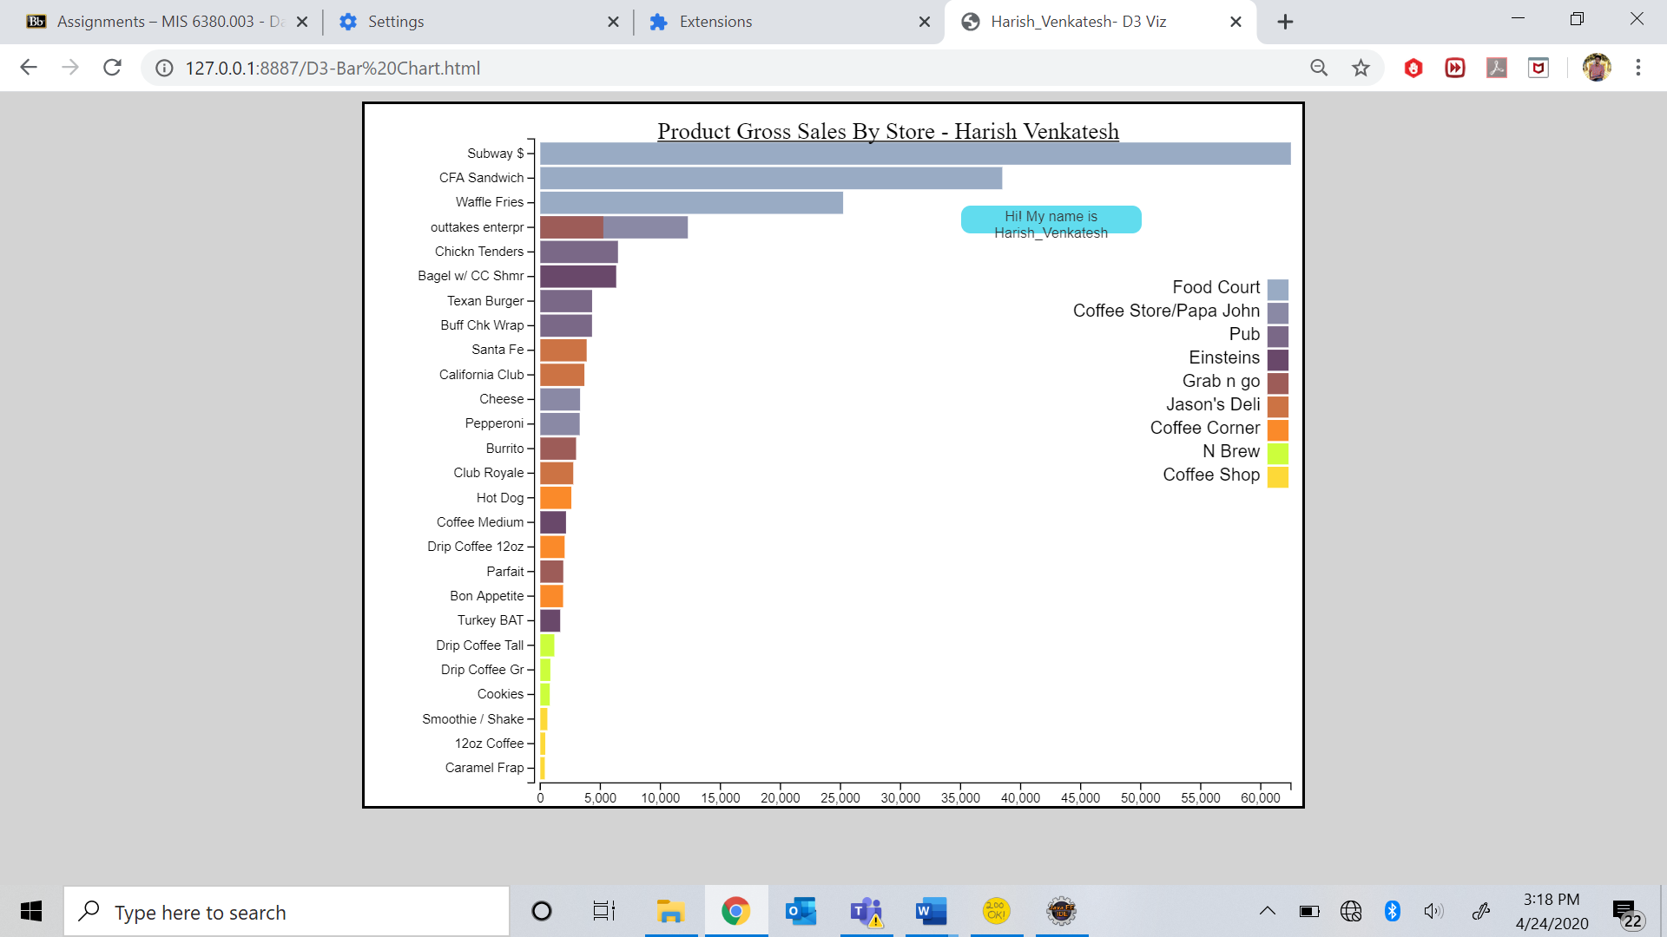

HOVERING OVER A BAR OF THE GRAPH DISPLAYING THE HIGHLIGHTING AND THE TOOLTIP.

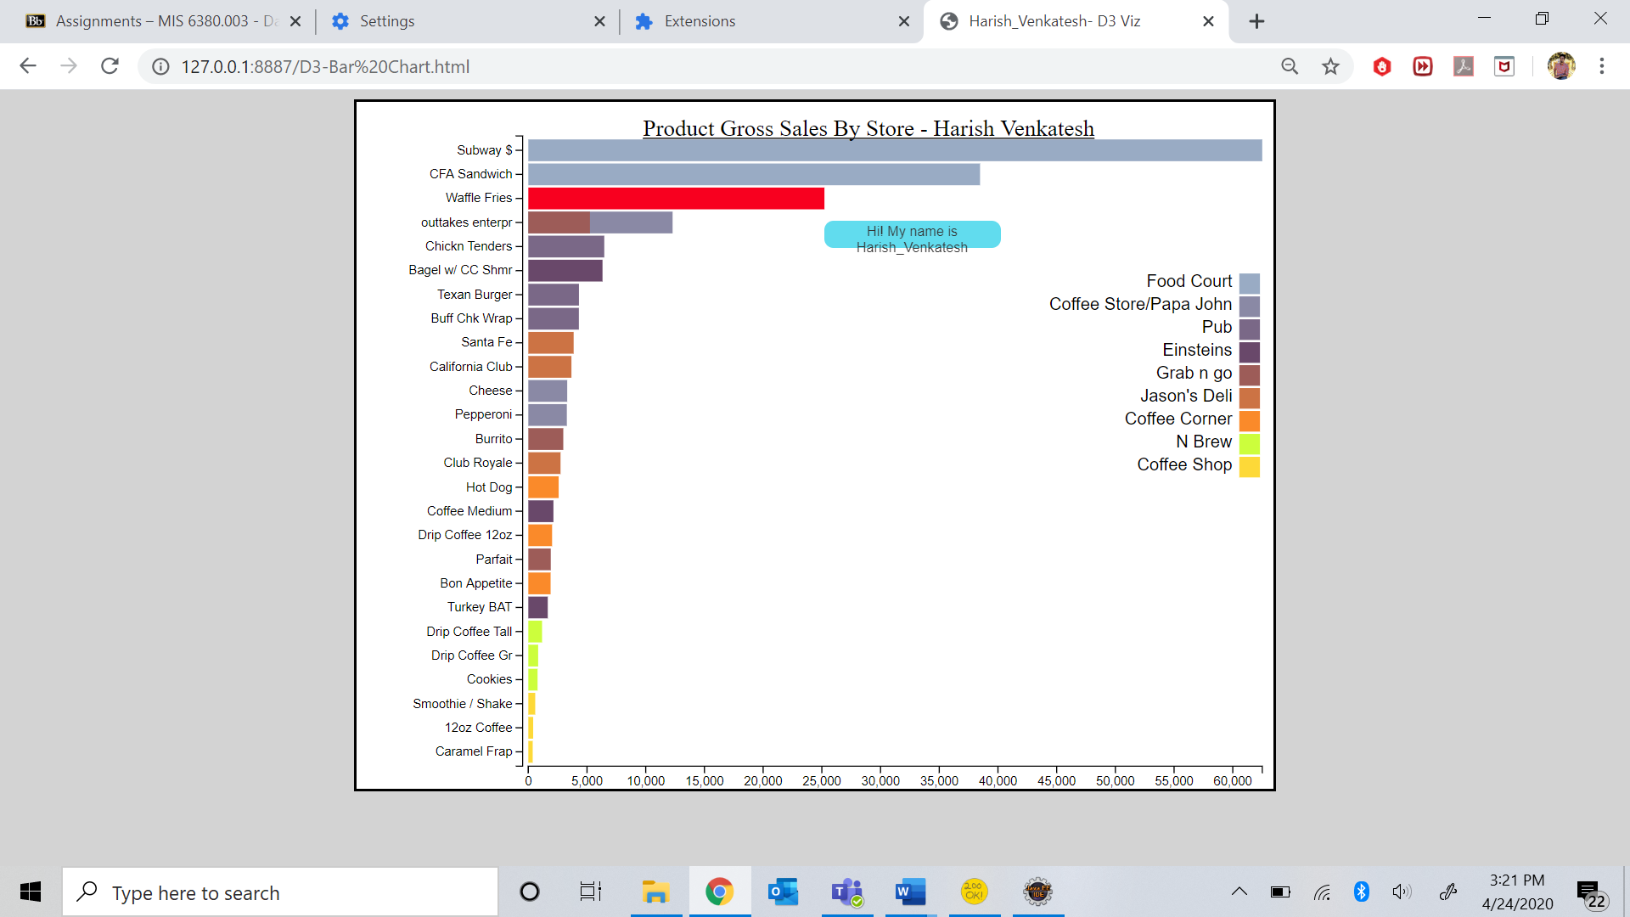

TOOLTIP SHOWING THE AVERAGE PRICE

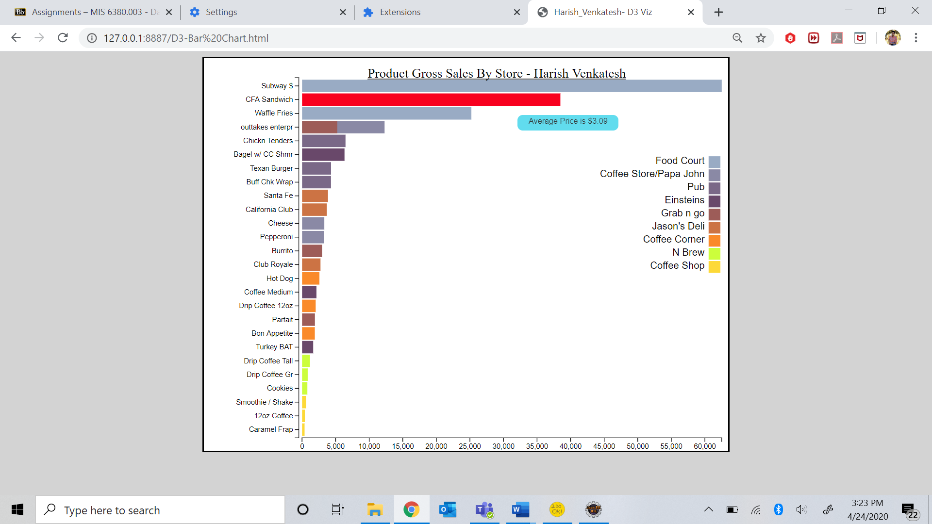

Adding DROPDOWN MENU

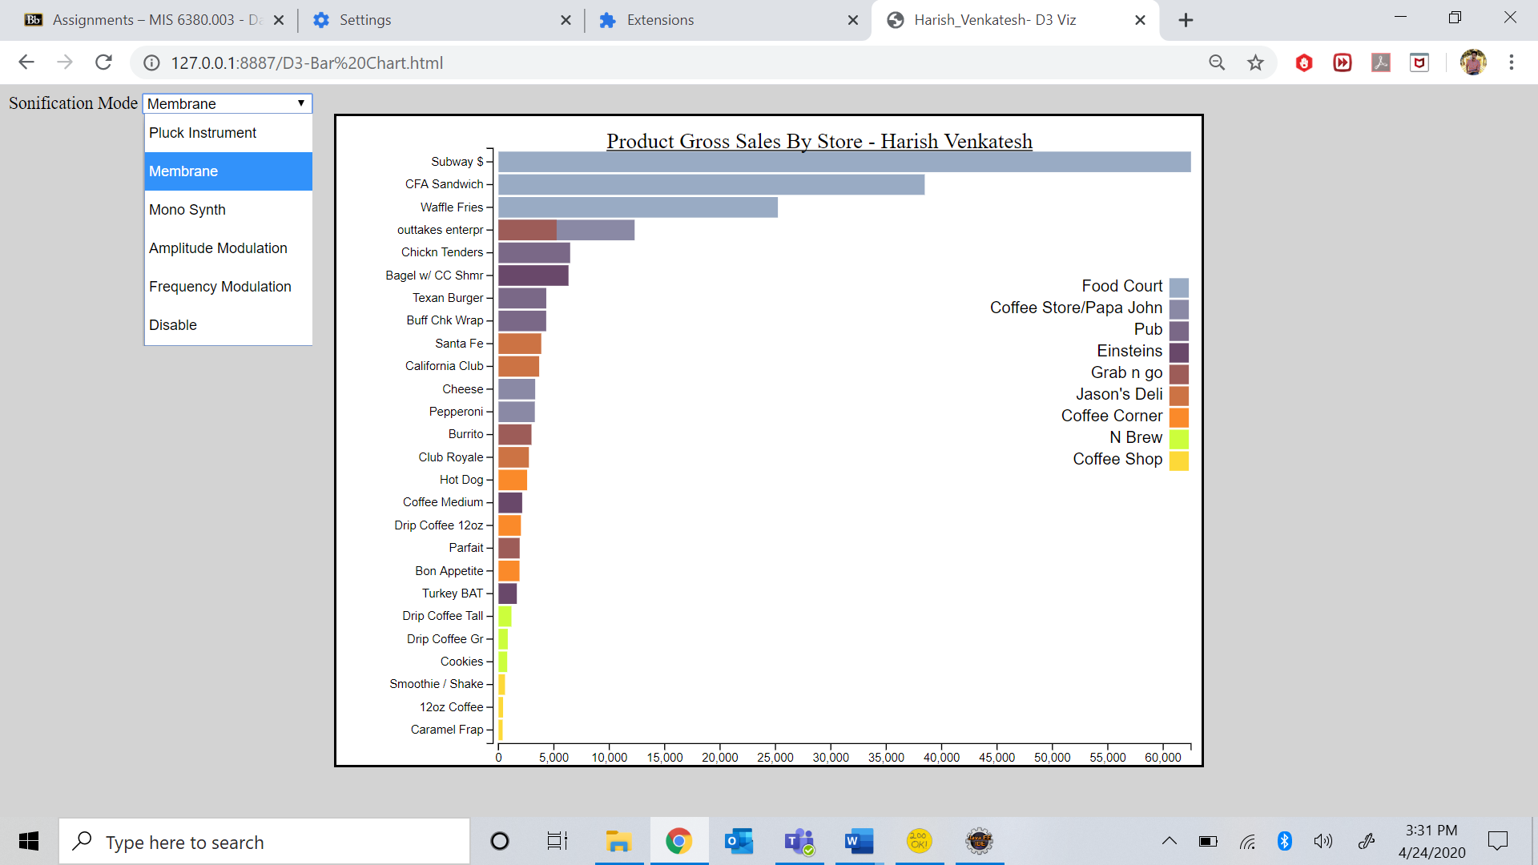

WHY DO YOU HEAR DIFFERENT FREQUENCY SOUNDS HERE?

freq = ((d.Price - in_min) * (out_max - out_min))/(in_max - in_min) + out_min;  
Here, the frequency variable is linked with the price variable and alters itself with change of price value. Therefore you hear sounds of different frequencies.